LY TU TRONG COLLEGE
HO CHI MINH CITY
INTRODUCTION
Established in 1986, Ly Tu Trong College of Ho Chi Minh City (LTTC) is one of the major public schools in Ho Chi Minh City which has the reputation for training quality of human resources to meet the demand of the workforce serving the socio-economic of the city and nationwide.
Owning a total area of 50,874m2, LTTC has an extensive green peaceful campus providing for learning, sports and entertainment for more than 10,000 students.
LTTC, with its 16 majors, offers students a wide range of professional programs specialized in Engineering, Economics and English. With well-qualified teaching staffs in sufficient quantity, LTTC commits to bring students high quality courses with reasonabletuition.
HISTORY
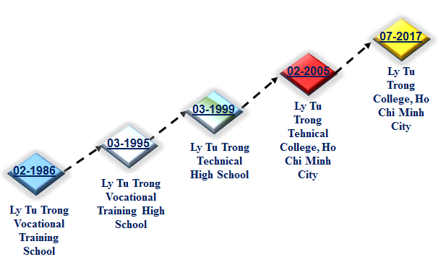
VISION
To develop Ly Tu Trong College of Ho Chi Minh City into an applied university of nation and become a multi - level and multi - disciplinary education institution with modern and advanced orientation in order to have a worthy position in higher education of Viet Nam and region, to meet the needs of high quality human resources for a special city and for industrialization and modernization of the country.
By 2020, Ly Tu Trong College of Ho Chi Minh City will become a high qualify training institution of country and meet ASEAN standards.
MISSION
Ly Tu Trong College of Ho Chi Minh City:
is a place to train human resources with prestige and high quality to meet the needs of society, enterprises and contribute to the process of industrialization and modernization of Ho Chi Minh City and the country.
is a place to combine training with the research and transfer of scientific research results in the field of professional training and technology for society
KEY VALUE OF LTTC OF HCMC
Knowledge – Creativity – Development – Sustainablility
ORGANIZATION STRUCTURE
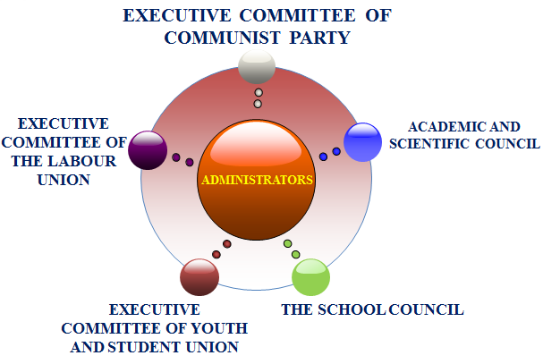
DEPARTMENTS
- Organization – Administration
- Admission - Training
- Planning and Finance
- Equipments and Materials
- Politics and Students
- Examination and Quality assurance
- Scientific management - International coorporation
- Facility management - Service
- Inspection – Legislation
CENTERS
- Information center - Library
- Ly Tu Trong Training Center
- Business Relation Center
- German Center
- Health care Center
STAFFS - TEACHERS – EMPLOYEES
Count to 12/2017, LTTC have 23 unit: 9 departments, 9 faculties, 5 centers.
Total: 332 employees
Total 280 lecturers with 04 PhD., 122 Master, 83% Graduated
LEVEL OF TRAINING PROGRAMS
Advanced associate degree (2.5 yrs)
Professional associate degree (2 yrs)
Professional associate degree (9+4 yrs)
Technician diploma (9 + 3 yrs)
Technician diploma (12 + 1 yrs)
In - service university degree
Transfer university degree (1.5 yrs)
SECTOR OF TRAINING
NO. | ASSOCIATE DEGREE
1 | Applied Information Technology
2 | Website Design
3 | Computer Engineering & Technology
4 | Computer Programming
5 | Network Security
6 | Computer Network Administration
7 | English
8 | Business Finance
9 | Business Accounting
10 | SME Business Administration
11 | Mechanical Engineering Technology
12 | Manufacturing Technology
13 | M&E Equipment Maintenance
14 | Maintenance of Industrial Equipment System
15 | Metal Cutting Engineering
16 | Automotive Engineering
17 | Electrostatic Coating Technology
18 | Thermal Engineering Technology
19 | Cooling Equipment Technology & Air Conditioning
20 | Operation and Maintenance of Refrigeration Equipment
21 | Refrigeration Equipment Installation
22 | Electronics – Electrical Engineering Technology
23 | Consumer Electronics
24 | Consumer Electric
25 | Electrical Installation Work
26 | Electrical Installation Technique & Industrial Control
27 | Telecomunications Technical Station
28 | Optical Transmission Technology and Radio
29 | Control Engineering Technology and Automation
30 | Automation Equipment Repair
31 | Mechatronics Engineering Technology
32 | External Network Techniques and Terminal
33 | Industrial Electronics
34 | Industrial Electric
35 | Garment Technology
36 | Fashion Design
37 | Garment - Fashion
38 | Veston Garment Technology
39 | Civil Engineering

NO. | TECHNICIAN DIPLOMA
1 | Applied Information Technology
2 | Website Design
3 | Computer Hardware Engineering & Technology
4 | Computer Programming
5 | Network Security
6 | Computer Network Administration
7 | English
8 | Business Finance
9 | Business Accounting
10 | SME Business Administration
11 | Mechanical Engineering Technology
12 | Welding Technology
13 | M&E Equipment Maintenance
14 | Machine Tool And Manufacturing Technology
15 | Maintenance of Industrial Equipment System
16 | Metal Cutting Engineering
17 | Automotive Engineering
18 | Electrostatic Coating Technology
19 | Car Painting Techniques
20 | Thermal Engineering Technology
21 | Cooling Equipment Technology & Air Conditioning
22 | Operation and Maintenance of Refrigeration Equipment
23 | Refrigeration Equipment Installation
24 | Electronics – Electrical Engineering Technology
25 | Consumer Electronics
26 | Consumer Electric
27 | Electrical Installation Work
28 | Electrical Installation Technique & Industrial Control
29 | Telecomunications Technical Station
30 | Optical Transmission Technology and Radio
31 | Automatic Control Engineering Technology
32 | Automation Equipment Repair
33 | Mechatronics Engineering Technology
34 | External Network Techniques and Terminal
35 | Industrial Electronics
36 | Industrial Electric
37 | Garment Technology - Fashion
38 | Fashion Design
39 | Garment - Fashion
40 | Veston Garment Technology
41 | Civil Engineering
TRANSFER DIAGRAM
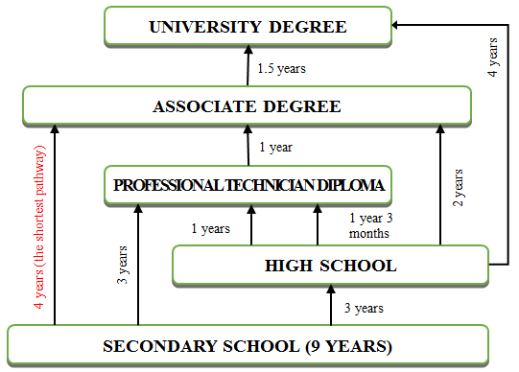
ADMISION AND CAPACITY
ASSOCIATE DEGREE | 8.346
1. Foundation Science | 104
2. Mechanical Engineering | 1.870
3. Information Technology | 1.047
4. Electrical - Electronics Engineering | 1.838
5. Automotive Engineering | 2.241
6. Thermal Engineering | 630
7. Garment Technology - Fashion | 432
8. Economics | 184

TECHNICIAN DEGREE | 3.082
1. Foundation Science | 96
2. Mechanical Engineering | 286
3. Information Technology | 670
4. Electrical - Electronics Engineering | 577
5. Automotive Engineering | 735
6. Thermal Engineering | 318
7. Garment Technology - Fashion | 156
8. Economics | 244
INTERNATIONAL COOPORATION
“Green Electrician” project is sponsored by Schneider Electric, DEG, ASSIST ASIA with 9.8 billions VND.
“Mechanical and Electrical (M&E) Professional Technician” project that is sponsored by KONE Corporation, DEG, with 15 billions VND for constructing a M&E technician Training Center in Elevator and Escalator training

CAREER OPPORTUNITIES
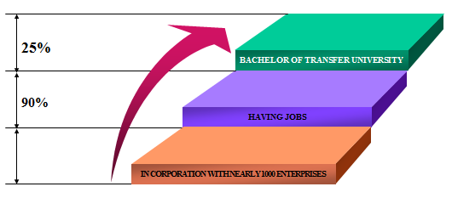
PHOTOS

